UNITED STATES
SECURITIES AND EXCHANGE COMMISSION
WASHINGTON, D.C. 20549

SCHEDULE 14A INFORMATION
Proxy Statement Pursuant to Section 14(a) of the
Securities Exchange Act of 1934
(Amendment No. )

Filed by the Registrant ☒

Filed by a party other than the Registrant ☐

Check the appropriate box:

☐ | Preliminary Proxy Statement
☐ | Confidential, for Use of the Commission Only (as permitted by Rule 14a-6(e)(2))
☐ | Definitive Proxy Statement
☒ | Definitive Additional Materials
☐ | Soliciting Material under Section 240.14a-12

Calavo Growers, Inc.
(Name of Registrant as Specified In Its Charter)

(Name of Person(s) Filing Proxy Statement, if other than the Registrant)

Payment of Filing Fee (Check all boxes that apply):

☒ | No fee required
☐ | Fee paid previously with preliminary materials
☐ | Fee computed on table in exhibit required by Item 25(b) per Exchange Act Rules 14a-6(i)(1) and 0-11

 | Your Vote Counts! You invested in CALAVO GROWERS, INC. and it’s time to vote! You have the right to vote on proposals being presented at the Annual Meeting. This is an important notice regarding the availability of proxy materials for the shareholder meeting to be held on April 23, 2025. Smartphone users Point your camera here and vote without entering a control number For complete information and to vote, visit www.ProxyVote.com Control # V62318-P25964 CALAVO GROWERS, INC. 2025 Annual Meeting Vote by April 22, 2025 11:59 PM ET CALAVO GROWERS, INC. 1141A CUMMINGS ROAD SANTA PAULA, CA 93060 ATTN: JAMES SNYDER Get informed before you vote View the Notice and Proxy Statement and Annual Report online OR you can receive a free paper or email copy of the material(s) by requesting prior to April 9, 2025. If you would like to request a copy of the material(s) for this and/or future shareholder meetings, you may (1) visit www.ProxyVote.com, (2) call 1-800-579-1639 or (3) send an email to sendmaterial@proxyvote.com. If sending an email, please include your control number (indicated below) in the subject line. Unless requested, you will not otherwise receive a paper or email copy. Vote in Person or Virtually at the Meeting* April 23, 2025 1:00 p.m., PDT 15765 W. Telegraph Road Santa Paula, California 93060 Or meeting live via the Internet-please visit www.virtualshareholdermeeting.com/CVGW2025 *Please check the meeting materials for any special requirements for meeting attendance. If you are attending the meeting in person, you will need to request a ballot to vote these shares.
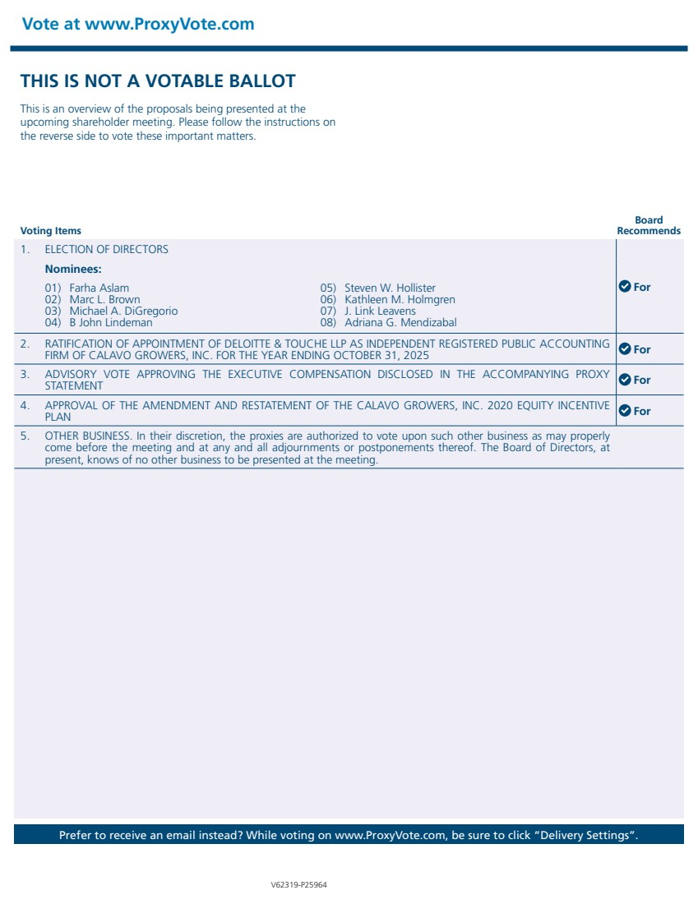 | THIS IS NOT A VOTABLE BALLOT This is an overview of the proposals being presented at the upcoming shareholder meeting. Please follow the instructions on the reverse side to vote these important matters. Vote at www.ProxyVote.com Prefer to receive an email instead? While voting on www.ProxyVote.com, be sure to click “Delivery Settings”. Voting Items Board Recommends V62319-P25964 1. ELECTION OF DIRECTORS For Nominees: 01) Farha Aslam 02) Marc L. Brown 03) Michael A. DiGregorio 04) B John Lindeman 05) Steven W. Hollister 06) Kathleen M. Holmgren 07) J. Link Leavens 08) Adriana G. Mendizabal 2. RATIFICATION OF APPOINTMENT OF DELOITTE & TOUCHE LLP AS INDEPENDENT REGISTERED PUBLIC ACCOUNTING FIRM OF CALAVO GROWERS, INC. FOR THE YEAR ENDING OCTOBER 31, 2025 For 3. ADVISORY VOTE APPROVING THE EXECUTIVE COMPENSATION DISCLOSED IN THE ACCOMPANYING PROXY STATEMENT For 4. APPROVAL OF THE AMENDMENT AND RESTATEMENT OF THE CALAVO GROWERS, INC. 2020 EQUITY INCENTIVE PLAN For 5. OTHER BUSINESS. In their discretion, the proxies are authorized to vote upon such other business as may properly come before the meeting and at any and all adjournments or postponements thereof. The Board of Directors, at present, knows of no other business to be presented at the meeting.

