Filed by Calavo Growers, Inc.

pursuant to Rule 425 under the Securities Act of 1933

and deemed filed pursuant to Rule 14a-12

under the Securities Exchange Act of 1934

Subject Company: Calavo Growers, Inc.

SEC File No.: 000-33385

Date: March 20, 2026
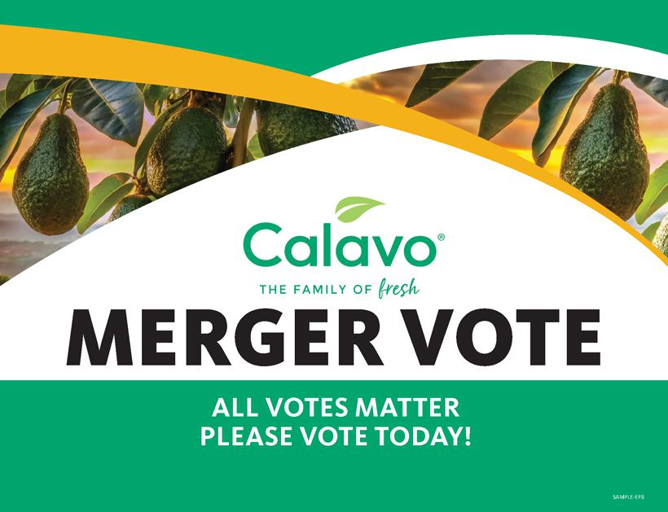



2

NO OFFER OR SOLICITATION

This document is not intended to be, and shall not constitute, an offer to buy or sell or the solicitation of an offer to buy or sell any securities, or a solicitation of any vote or approval, nor shall there be any sale of securities in any jurisdiction in which such offer, solicitation or sale would be unlawful prior to registration or qualification under the securities laws of any such jurisdiction. No offering of securities shall be made, except by means of a prospectus meeting the requirements of Section 10 of the Securities Act of 1933, as amended.

IMPORTANT ADDITIONAL INFORMATION FILED WITH THE SEC

In connection with the proposed transaction between Calavo Growers, Inc. (“Calavo”) and Mission Produce, Inc. (“Mission Produce”) pursuant to that certain Agreement and Plan of Merger dated January 14, 2026 among Calavo, Mission Produce, and certain subsidiaries of Mission Produce, Mission Produce initially filed with the Securities and Exchange Commission (the “SEC”) a registration statement on Form S-4 (File Number 333-294128) (the “Registration Statement”) on March 9, 2026 and subsequently amended the Registration Statement on March 18, 2026. The Registration Statement includes a joint proxy statement of Calavo and Mission Produce, which also constitutes a prospectus of Mission Produce (the “Joint Proxy Statement/Prospectus”). The Registration Statement was declared effective by the SEC on March 20, 2026 and Calavo filed a definitive Joint Proxy Statement/Prospectus on that date. Calavo intends to first mail the definitive Joint Proxy Statement/Prospectus to Calavo shareholders on March 25, 2026. Each of Calavo and Mission Produce may also file other relevant documents with the SEC regarding the proposed transaction. This document is not a substitute for the Joint Proxy Statement/Prospectus or Registration Statement or any other document that Calavo or Mission Produce may file with the SEC. INVESTORS AND SECURITY HOLDERS ARE URGED TO READ THE REGISTRATION STATEMENT, JOINT PROXY STATEMENT/PROSPECTUS AND ANY OTHER RELEVANT DOCUMENTS THAT MAY BE FILED WITH THE SEC, AS WELL AS ANY AMENDMENTS OR SUPPLEMENTS TO THOSE DOCUMENTS CAREFULLY AND IN THEIR ENTIRETY IF AND WHEN THEY BECOME AVAILABLE BECAUSE THEY CONTAIN OR WILL CONTAIN IMPORTANT INFORMATION ABOUT CALAVO, MISSION PRODUCE AND THE PROPOSED TRANSACTION.

3

Investors and security holders are able to obtain free copies of the Registration Statement and Joint Proxy Statement/Prospectus and other documents containing important information about Calavo, Mission Produce and the proposed transaction through the website maintained by the SEC at http://www.sec.gov. Copies of the Registration Statement and Joint Proxy Statement/Prospectus and other documents filed with the SEC by Calavo may be obtained free of charge on Calavo’s website at www.ir.calavo.com/financial-information/sec-filings or, alternatively, by directing a request by mail to Calavo’s Corporate Secretary at Attention: Corporate Secretary, Calavo Growers, Inc., 1141A Cummings Road, Santa Paula, CA 93060. Copies of the Registration Statement and Joint Proxy Statement/Prospectus (if and when available) and other documents filed with the SEC by Mission Produce may be obtained free of charge on Mission Produce’s website at www. investors.missionproduce.com/financial-information/sec-filings or, alternatively, by directing a request by mail to Mission Produce’s Corporate Secretary at Attention: Corporate Secretary, Mission Produce, 2710 Camino Del Sol, Oxnard, CA 93030.

PARTICIPANTS IN THE SOLICITATION

Calavo, Mission Produce and their respective directors and executive officers may be deemed to be participants in any solicitation of proxies in connection with the proposed transaction. Information about Calavo’s directors and executive officers is available in Calavo’s Annual Report on Form 10-K for the year ended October 31, 2025, as amended. Information about Mission Produce’s directors and executive officers is available in Mission Produce’s annual report on Form 10-K for the year ended October 31, 2025, and proxy statement for Mission Produce’s 2026 Annual Meeting of Stockholders, which was filed with the SEC on February 24, 2026. Other information regarding the participants in the proxy solicitation and a description of their direct and indirect interests, by security holdings or otherwise, is contained in the Registration Statement and Joint Proxy Statement/Prospectus, and all other relevant materials filed or to be filed with the SEC regarding the proposed transaction when such materials become available. Investors should read the Registration Statement and Joint Proxy Statement/Prospectus carefully before making any voting or investment decisions.

4

